**Understanding Treatment-Resistant Depression (TRD)**

**Overview & Definition of TRD**

Treatment-Resistant Depression (TRD) is a significant clinical challenge where individuals with Major Depressive Disorder (MDD) do not respond adequately to standard antidepressant treatments. A major hurdle in understanding TRD is the lack of a single, universally accepted definition. Different organizations and studies use varying criteria, leading to a wide range of prevalence estimates and making direct comparisons difficult. Key aspects that vary include the number of failed antidepressant trials, how "treatment failure" is measured, and the required duration and dosage of medications.

**Comparing definitions of US and the Global**

There are some criteria commonly used to **TRD between the** define TRD, but their specifics can vary significantly:



**Prevalence of TRD**

Understanding the prevalence of TRD is vital for healthcare planning and resource allocation. However, due to the definitional challenges mentioned earlier, reported rates vary significantly across studies and regions.

US Genneral (MDD Pts)

* Rate: 35%
* Details: Approx. 30%~40% of individuals with MDD experience TRD

US Claims (PTD Pts)

* Rate: 6.3%
* Details: 5.8–6.8 % of pharmaceutically treated depression patients (Humana/Optum databases).

UK Study (Secondary Care MDD Pts)

* Rate: 47.9%
* Details: Nonresponse to ≥ 2 adequate AD trials, then 3rd strategy/augmentation.

Ethiopian Study (MDD Follow-up Pts)

* Rate: 41.5%
* Details: HADS-D score ≥ 8.

Danish Study (1st Hospital Contact for Depression)

* Rate: 14%
* Details: Second shift in AD treatment within 12 months (range 13–31 % with other definitions).

Notes:

* **HADS-D**: Hospital Anxiety and Depression Scale – Depression subscale
* **EHR**: Electronic Health Records

**Esketamine vs. Ketamine: A Market Deep Dive**

**Understanding the Molecules & Regulatory Landscape**

The therapeutic landscape for mental health and pain management is significantly influenced by NMDA receptor antagonists, notably ketamine and its S(+) enantiomer, esketamine. While chemically related, they have distinct regulatory profiles, primary uses, and market dynamics. **Esketamine** (*Spravato*) is an FDA-approved, REMS-controlled **nasal spray for TRD**. **Ketamine** **is an older anaesthetic** also used extensively off-label for mental health conditions, leading to different market access and oversight.

**Esketamine (Spravato) Market Insights (Global Focus)**

The global esketamine market, driven by Spravato, is experiencing robust growth. It targets TRD and benefits from strong pharmaceutical backing and favourable regulatory approvals in many countries. North America is the dominant region.Asignificant driver for esketamine is the high prevalence of TRD. Esketamine offers a vital, FDA-approved option for this challenging condition.

**Ketamine Market Landscape (Global & US Focus)**

**Ketamine**'s market is diverse, covering anaesthesia, pain management, and rapidly expanding off-label mental health uses. The mental health segment, particularly in the US via clinics, shows significant growth, driven by unmet needs and flexible administration, though **with less regulatory oversight than esketamine.**

**Head-to-Head: Esketamine vs. Ketamine**

While both address similar patient needs, **esketamine** and off-label ketamine operate under vastly different market and regulatory conditions. This comparison highlights key differences in market size and regulatory pathways.

**Simplified Regulatory Pathways for Mental Health Use**

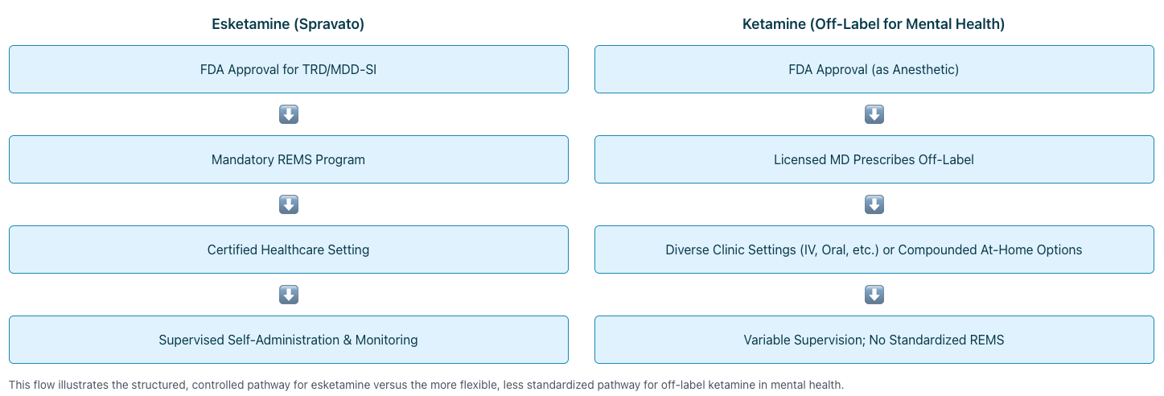

**Future Outlook**

Both markets are poised for continued expansion. Esketamine will leverage its FDA-approved status and strong clinical data. Ketamine's off-label use will grow due to accessibility, but faces potential regulatory shifts. The overarching driver is the persistent global need for better mental health treatments.

**The Shifting Landscape of Depression Treatment Costs**

An Analysis of Esketamine (*Spravato*) vs. Ketamine Pricing in the U.S. Market

**The Financial Realities of Advanced Depression Therapies**

The introduction of novel treatments like esketamine (*Spravato*) and the expanded off-label use of ketamine offer new hope for individuals with treatment-resistant depression. However, navigating their complex pricing structures, FDA approval statuses, and insurance coverage presents significant financial challenges. This analysis delves into the average single-dose and overall treatment costs, highlighting key market dynamics influencing patient access and affordability in the United States.

All costs presented are generally based on "without insurance" scenarios unless otherwise specified, reflecting the initial financial consideration for many patients.

**Spotlight on Esketamine (*Spravato*®)**

Cost Structure (Without Insurance)

Per Treatment Session:

* **56mg Dose: $590 – $725**
* **84mg Dose: $720 – $885**

Initial Induction Phase (first month, twice weekly):

* **Approximately $4,720 – $7,080** (drug, administration, and monitoring)

* **Insurance & Patient Assistance**

Spravato's FDA approval makes it eligible for commercial insurance, Medicare Part B, and Medicaid. Out-of-pocket costs with insurance can be significantly lower, potentially $10-$250 per session. Manufacturer programs like "Spravato withME" can further reduce copays for eligible commercially insured patients to as low as $10/session (up to $8,150 annual savings).

**Market Impact:**

Despite a high list price, insurance and assistance programs are designed to improve affordability and market penetration for eligible patients, a common strategy for speciality FDA-approved drugs.

**Spot on Ketamine (Various Formulations)**

Ketamine is FDA-approved as an anaesthetic. Its use for depression and other mental health conditions is "off-label." Administered via multiple routes: Intravenous (IV), Intramuscular (IM), Oral, Sublingual (SL), and Compounded Intranasal sprays. **The "off-label" status for depression is the primary reason it's generally NOT covered by insurance, leading to predominantly out-of-pocket expenses for patients.**

Cost Variations by Type (Without Insurance)

Average Cost Per Single Dose/Session:

* IV Infusion: $300 – $1,000+
* IM Injection: $200 – $600
* Oral/Sublingual: $50 – $200 (per prescription/dose)
* Compounded Intranasal: $60 – $300 (per prescription/dose)

Prices vary by clinic location, facility type, and lack of regulation for off-label use pricing.

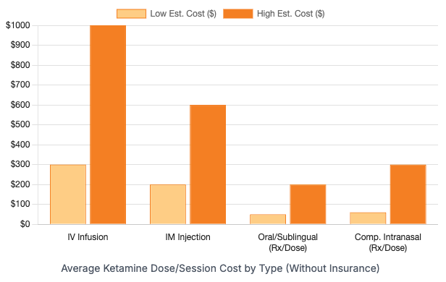

* **The Insurance Barrier for Off-Label Ketamine**

Due to its off-label status for depression, ketamine treatments (IV, IM, oral, etc.) are rarely covered by insurance. Patients typically bear 100% of the cost. This creates a significant financial hurdle, regardless of potentially lower per-dose costs for some formulations compared to Spravato's list price. The market operates on a cash-pay basis, leading to wide price variability.

**Market Impact:**

The lack of insurance coverage for off-label ketamine for depression results in a two-tiered system, heavily favouring patients who can afford substantial out-of-pocket costs.

**Single Dose/Session Cost: A Direct Look**

While a direct "per dose" comparison seems straightforward, it's crucial to remember the bundled nature of Spravato's costs (including monitoring) versus the often unbundled costs for ketamine services.

**Esketamine (*Spravato*) Session:**

**$590 - $885**

(Includes drug, administration & mandatory 2-hr monitoring)

**Ketamine (Monitoring/facility fees may be separate for ketamine):**

IV Infusion: **$300 - $1,000+**

Oral/Sublingual (per dose/Rx): **$50 - $300**

A lower single-dose price for some ketamine forms doesn't automatically mean lower overall patient out-of-pocket costs for a full treatment course, primarily due to the insurance factor.

**Beyond the Single Dose: Total Treatment & Ancillary Costs**

Effective treatment often involves a series of sessions and supportive therapies. These cumulative costs paint a more realistic financial picture.

**Illustrative Initial Course Costs (Without Insurance)**

**Spravato (Induction - 1 month):** $4,720 - $7,080

**Ketamine IV (6-8 infusions):** $2,100 - $6,000

The chart below provides a visual comparison for an initial treatment period, highlighting the significant financial commitment involved, especially when insurance is not a factor or ancillary services are added.

**Key Ancillary Costs (Often Out-of-Pocket)**

* **Psychotherapy:** $100 - $200 per hour (often recommended alongside ketamine/Esketamine)
* **Medication Management:** $300+ per session (to optimise overall psychiatric care)
* **Booster Sessions:** Required by some patients to maintain benefits, adding to long-term costs.
* **Consultation Fees:** $50 - $300+ for initial suitability assessment.

**Holistic Financial View:**

The true cost of treatment extends far beyond the medication itself, encompassing a suite of services that can dramatically increase the patient's financial burden, especially for off-label ketamine, which is also unlikely to be insured.